A
Summer Internship Report
On
“Student Placement Prediction and Analysis Using Data Science”
(CSE306 – Summer Internship-I)

Prepared by
Patel Princekumar (24CS073)

Under the Supervision of
Prof. Hemang Thakar
Submitted to
Charotar University of Science & Technology (CHARUSAT)
for the Partial Fulfillment of the Requirements for the
Degree of Bachelor of Technology (B.Tech.)
for Semester 5
Submitted at



DEPARTMENT OF COMPUTER SCIENCE & ENGINEERING
Chandubhai S. Patel Institute of Technology (CSPIT)
Faculty of Technology & Engineering (FTE), CHARUSAT
At: Changa, Dist: Anand, Pin: 388421.
July 2026


Accredited with Grade A⁺ byNAAC
Accredited with Grade A⁺ by KCG

CERTIFICATE
This is to certify that the report entitled “Student Placement Prediction and Analysis Using Data Science” is a bonafied work carried out by Patel Princekumar (24CS073) under the guidance and supervision of Prof. Hemang Thakar and Mr. Sumit Jadav for the subject Summer Internship-I (CSE306) of 5th Semester of Bachelor of Technology in Computer Science & Engineering at Chandubhai S. Patel Institute of Technology (CSPIT), Faculty of Technology & Engineering (FTE) – CHARUSAT, Gujarat.
To the best of my knowledge and belief, this work embodies the work of candidate himself, has duly been completed, and fulfills the requirement of the ordinance relating to the B.Tech. Degree of the University and is up to the standard in respect of content, presentation and language for being referred by the examiner(s).
Under the supervision of,  Prof. Hemang Thakar  Assistant Professor  Dept. of Computer Science & Engineering  CSPIT, FTE, CHARUSAT, Changa, Gujarat | Mr. Sumit Jadav  AI/ML Developer  Sparks To Ideas  Ahmedabad, Gujarat
Dr. Amit Thakkar
Head - Department of Computer Science & Engineering,
CSPIT, FTE, CHARUSAT, Changa, Gujarat.
Chandubhai S. Patel Institute of Technology (CSPIT) Faculty of Technology & Engineering (FTE), CHARUSAT
AT: Changa, Ta. Petlad, Dist. Anand, Pin: 388421. Gujarat.

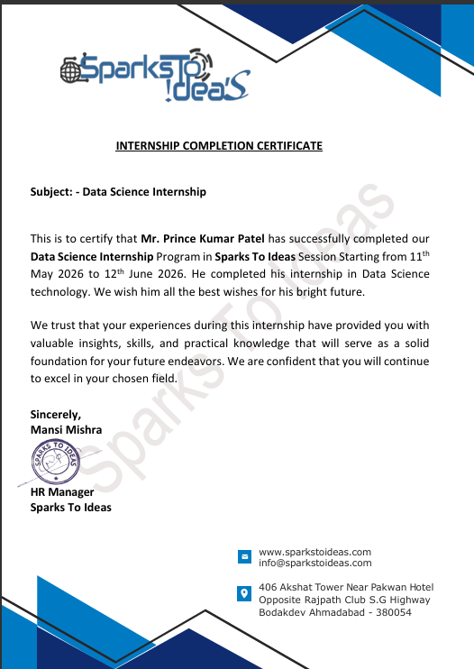

ACKNOWLEDGEMENT
I would like to express my sincere gratitude to all those who supported and guided me throughout my summer internship and the completion of this project report.
First of all, I am thankful to Sparks To Ideas, Ahmedabad, for giving me the opportunity to undergo my summer internship in the field of Data Science. I am especially grateful to my external guide, Mr. Sumit Jadav (AI/ML Developer, Sparks To Ideas), for the continuous guidance, valuable suggestions and practical knowledge which helped me to complete this project successfully.
I express my deep sense of gratitude to my internal guide, Prof. Hemang Thakar, Assistant Professor, Department of Computer Science & Engineering, CSPIT, CHARUSAT, for the constant support, encouragement and valuable guidance during the internship period.
I am also thankful to Dr. Amit Thakkar, Head of the Department of Computer Science & Engineering, and to Chandubhai S. Patel Institute of Technology (CSPIT), CHARUSAT, for providing this platform of summer internship as a part of the curriculum.
Finally, I would like to thank my family and friends for their constant motivation and support throughout the internship.
Patel Princekumar (24CS073)

ABSTRACT
Campus placement is one of the most important milestones in a student’s academic journey, and educational institutions constantly strive to improve their placement records. The project “Student Placement Prediction and Analysis Using Data Science” aims to predict whether a student is likely to be placed or not based on his/her academic and personal attributes, using machine learning based classification techniques.
During the summer internship at Sparks To Ideas, Ahmedabad, a complete data science workflow was carried out on a student placement dataset. The work included data collection, data cleaning, exploratory data analysis (EDA), feature engineering, encoding of categorical variables, and training of multiple classification models such as Logistic Regression, Decision Tree and Random Forest. The performance of these models was compared using evaluation metrics like accuracy, precision, recall, F1-score and confusion matrix.
The best performing model, Logistic Regression, achieved an accuracy of about 80.85% on the test dataset. The analysis also highlighted the key factors influencing placement, such as academic percentages, work experience and technical skills. The final model can help the training and placement cell to identify students who need additional support and training, thereby improving the overall placement performance of the institute.

DESCRIPTION OF COMPANY / ORGANIZATION
Company Name: Sparks To Ideas
Address: 406 Akshat Tower, Near Pakwan Hotel, Opposite Rajpath Club, S.G. Highway, Bodakdev, Ahmedabad – 380054, Gujarat, India
Website: www.sparkstoideas.com | E-mail: info@sparkstoideas.com
Internship Duration: 11th May 2026 to 12th June 2026
Technology / Domain: Data Science (Machine Learning Based Classification Project)
Sparks To Ideas is an IT training and software development company located in Ahmedabad, Gujarat. The company provides industrial training, summer internships and professional development programs for engineering students in the latest technologies such as Data Science, Machine Learning, Artificial Intelligence, Python, Web Development and Mobile Application Development.
The company focuses on bridging the gap between academic knowledge and industry requirements by providing hands-on, project-based learning under the guidance of experienced industry mentors. During the internship, students work on live projects and real-world datasets which help them develop practical and professional skills. The training sessions are conducted by industry professionals and each intern is guided personally throughout the project development.

TABLE OF CONTENTS
Acknowledgement iv
Abstract v
Description of Company / Organization vi
List of Figures ix
List of Tables x
Chapter 1 Introduction………………………………………………………………… 11
1.1 Internship Objectives…………………………………………………………….. 11
1.2 Overview of Internship Activities………………………………………………... 12
Chapter 2 Tools and Technologies…………………………………………………….. 15
2.1 Introduction to MySQL…………………………………………………………... 15
2.2 Introduction to Python…………………………………………………………….16
2.2.1 Introduction to Keras……………………………………………………………………….. 17
2.2.2 Introduction to NumPy…………………………………………………………………….. 18
2.3 Hardware Requirements………………………………….…………...…..……………19
2.4 Software Requirements…………………………………………………………… 19
Chapter 3 Task Description…………………………………………………………… 20
3.1 Task 1 …..……………………………………………………………………….. 20
3.2 Task 2 …………………………………………………………………………… 20
3.2.1 Data-Dictionary………………………………………………………………….21
3.3 Task 3 ……………………………………………………………………………. 22
3.4 Task 4 ……………………………………………………………………………. 23
3.4.1 Class Diagram………….…………………………………………………………. 24
3.4.2 ER Diagram………………………………………………………………………...25
3.4.3 Activity Diagram………………………………………………………………...…26
3.4.4 Use Case Diagram………………………………………………………………….27
3.5 Task 5…………………………………………………………………………….. 28
3.6 Task 6 ……………………………………………………………………………. 30
3.7 Task 7 ……………………………………………………………………………. 30
Chapter 4 Learning Experiences……………………………………………………… 32
4.1 Knowledge Acquired/Skills Learnt……………………………………………… 32
4.2 Industry Practices Adapted………………………………………………………. 33
4.3 Real-Time Applicability of Technologies Learnt………………………………... 34
Chapter 5 Conclusion………………………………………………………………….. 36
5.1 Future Scope………………………….………………………………………….37
5.2 Limitations ………………………………………………………………………..37
References………………………………………………………………………………. 38

LIST OF FIGURES
Figure Name | Page No.
Fig 1.1 Workflow of the Proposed System | 14
Fig 3.1 Dataset Loading and Preview | 21
Fig 3.2 Distribution of Placement Status | 22
Fig 3.3 Correlation Heatmap of Dataset Attributes | 23
Fig 3.4 Class Diagram of Student Placement Prediction System | 24
Fig 3.5 ER Diagram of Student Placement Prediction System | 25
Fig 3.6 Activity Diagram | 26
Fig 3.7 Use Case Diagram | 27
Fig 3.8 Model Training Using Machine Learning Algorithms | 28
Fig 3.9 Model Accuracy Comparison | 29
Fig 3.10 Confusion Matrix of the Selected Model | 29
Fig 3.11 Placement Prediction Output | 30

LIST OF TABLES
Table Name | Page No.
Table 2.1 Hardware Requirements | 19
Table 2.2 Software Requirements | 19
Table 3.2.1 Data Dictionary of Placement Dataset | 21

CHAPTER 1 INTRODUCTION

Summer Internship-I is an integral part of the Bachelor of Technology curriculum that enables students to bridge the gap between academic learning and industrial practices. It provides an opportunity to gain practical exposure to real-world technologies, understand professional work culture, and apply theoretical concepts to solve industry-oriented problems.

During this internship at Sparks To Ideas, Ahmedabad, the primary focus was on the field of Data Science and Machine Learning. The internship provided practical training in Python programming, data preprocessing, exploratory data analysis (EDA), feature engineering, machine learning algorithms, model evaluation, and project development using real-world datasets. The training sessions combined theoretical concepts with hands-on implementation, allowing interns to understand the complete lifecycle of a data science project.

As part of the internship, the project "Student Placement Prediction and Analysis Using Data Science" was developed. The objective of the project was to analyze historical placement data and predict whether a student is likely to be placed based on academic performance, technical skills, training, and other relevant factors. The project involved data collection, preprocessing, visualization, model development, performance evaluation, and prediction using machine learning techniques.

The internship also helped in developing professional competencies such as analytical thinking, problem solving, teamwork, technical documentation, communication, and time management. It provided valuable exposure to industry practices and enhanced the understanding of how data-driven solutions are developed to address real-world problems.
  - INTERNSHIP OBJECTIVES
The major objectives of the internship are as follows:
- To understand the practical implementation of Data Science and Machine Learning concepts in an industrial environment.
- To strengthen programming skills using Python and its data science libraries.
- To learn the complete machine learning workflow, including data collection, preprocessing, visualization, model building, evaluation, and prediction.
- To analyze a real-world student placement dataset and identify the factors affecting placement opportunities.
- To build and compare multiple machine learning classification models for placement prediction.
- To evaluate the performance of different models using standard evaluation metrics such as Accuracy, Precision, Recall, F1-Score, and Confusion Matrix.
- To improve professional skills including teamwork, communication, documentation, presentation, and project management.
- To understand industrial software development practices and project execution methodologies.

  - OVERVIEW OF INTERNSHIP ACTIVITIES
- The internship was conducted at Sparks To Ideas, Ahmedabad, from 11 May 2026 to 12 June 2026. During this period, various technical sessions and practical assignments were completed to develop a strong foundation in Data Science and Machine Learning.
- The internship began with an introduction to the company, internship guidelines, and the overall project roadmap. The initial phase focused on revising Python programming concepts and learning essential libraries such as NumPy, Pandas, Matplotlib, and Seaborn. These libraries were extensively used for numerical computation, data manipulation, and visualization.
- After gaining familiarity with the required tools, the student placement dataset was studied in detail. The dataset was cleaned by handling missing values, removing inconsistencies, and transforming categorical variables into numerical formats suitable for machine learning algorithms. Exploratory Data Analysis (EDA) was then performed to identify trends, distributions, correlations, and significant features affecting placement.
- The next stage involved developing machine learning models using Scikit-learn. Logistic Regression, Decision Tree, and Random Forest classifiers were implemented and trained using the processed dataset. Their performances were evaluated using multiple evaluation metrics, and the best-performing model was selected based on prediction accuracy and overall reliability.
- The internship concluded with testing the prediction model using unseen student records, documenting the complete project, preparing the internship report, and presenting the project outcomes to the mentors. Throughout the internship, practical exposure to real-world data analysis and machine learning development significantly enhanced both technical knowledge and professional skills.

INTERNSHIP WORKFLOW :-
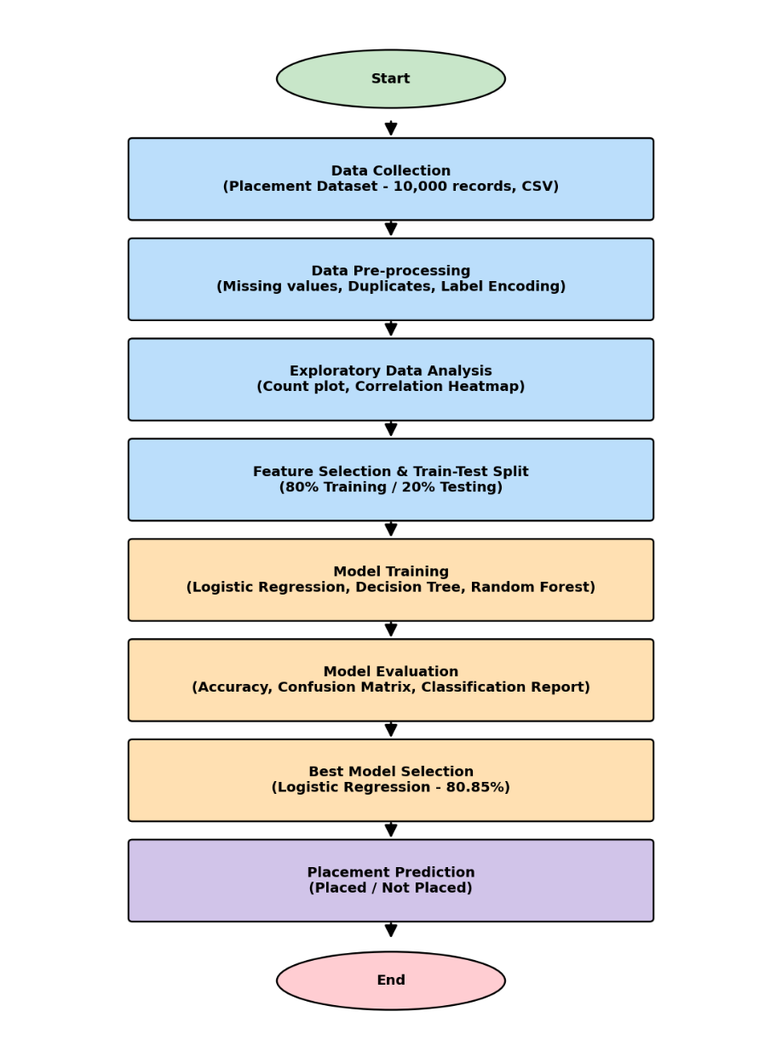
Fig. 1.1 Workflow of the Proposed System
Explanation: The workflow illustrates the complete process followed during the project, starting with dataset collection and preprocessing, followed by exploratory data analysis, feature selection, machine learning model training, model evaluation, and final placement prediction.

CHAPTER 2 TOOLS AND TECHNOLOGIES

The successful development of the Student Placement Prediction and Analysis Using Data Science project required the use of various programming languages, software tools, libraries, and hardware resources. During the internship, these technologies were used to perform data collection, preprocessing, visualization, machine learning model development, and evaluation. Each tool played an important role in different stages of the project development lifecycle.
2.1 INTRODUCTION TO MYSQL

MySQL is a widely used open-source Relational Database Management System (RDBMS) developed by Oracle Corporation. It is used to store, organize, retrieve, and manage structured data efficiently using Structured Query Language (SQL).

Although the primary dataset for this project was stored in CSV format, MySQL was introduced during the internship to understand database management concepts and the storage of structured data. Learning MySQL helped in understanding how large datasets can be managed in real-world applications before they are processed using machine learning techniques.

Features of MySQL

Open-source and freely available.

Supports SQL for efficient data manipulation.

Provides high performance and reliability.

Ensures data consistency through relational tables.

Supports indexing for faster data retrieval.

Compatible with multiple programming languages including Python.

Applications of MySQL

Student Management Systems

Banking Applications

Hospital Management Systems

E-commerce Websites

Data Storage for Machine Learning Projects

Enterprise Information Systems
2.2 INTRODUCTION TO PYTHON
Python is a high-level, interpreted, object-oriented programming language developed by Guido van Rossum. It is one of the most popular programming languages for Data Science, Artificial Intelligence, and Machine Learning because of its simple syntax, readability, and extensive collection of libraries.
Throughout the internship, Python served as the primary programming language for implementing the complete machine learning workflow, including data preprocessing, visualization, model development, evaluation, and prediction.
Features of Python
- Easy to learn and understand.
- Open-source and platform-independent.
- Rich collection of libraries for Data Science.
- Supports Object-Oriented Programming.
- Large community support.
- Rapid application development.
- Excellent integration with databases and web applications.
Role of Python in the Project
Python was used for:
- Reading and processing the placement dataset.
- Cleaning and transforming data.
- Performing Exploratory Data Analysis (EDA).
- Building machine learning models.
- Evaluating model performance.
- Predicting student placement status.
2.2.1 INTRODUCTION TO KERAS

Keras is an open-source Deep Learning library that provides a high-level interface for building Artificial Neural Networks. It is built on top of TensorFlow and simplifies the development of deep learning models.

Although the final project mainly used traditional machine learning algorithms such as Logistic Regression, Decision Tree, and Random Forest, Keras was introduced during the internship to provide an understanding of neural networks and modern deep learning techniques.

Features of Keras

User-friendly interface.

Fast model development.

Built on TensorFlow.

Supports deep neural networks.

Easy model training and evaluation.

Suitable for research and production environments.

Applications of Keras

Image Classification

Speech Recognition

Natural Language Processing

Medical Diagnosis

Recommendation Systems

Predictive Analytics
2.2.2 INTRODUCTION TO NUMPY

NumPy (Numerical Python) is one of the most important Python libraries for scientific computing. It provides powerful multidimensional arrays and mathematical functions for performing numerical computations efficiently.

During the internship, NumPy was used to manipulate numerical data, perform mathematical calculations, and support preprocessing tasks required for machine learning algorithms.

Features of NumPy

High-performance multidimensional arrays.

Fast numerical computation.

Mathematical and statistical functions.

Memory-efficient data storage.

Applications of NumPy

Matrix Operations

Linear Algebra

Statistical Analysis

Scientific Computing

Machine Learning

Data Preprocessing

2.3 HARDWARE REQUIREMENTS
Component | Minimum Requirement
Processor | Intel Core i3 or equivalent processor
RAM | 4 GB or above (8 GB recommended)
Hard Disk | 256 GB or above
Display | Standard monitor / laptop display
Internet Connection | Required for dataset download, documentation, and software installation
Table 2.1 Hardware Requirements

2.4 SOFTWARE REQUIREMENTS
Software | Details
Operating System | Windows 10 / 11
Programming Language | Python 3.11
IDE / Environment | Jupyter Notebook / Google Colab / VS Code
Libraries | NumPy, Pandas, Matplotlib, Seaborn, Scikit-learn
Dataset | placementdata.csv (10,000 student records, 12 attributes)
Table 2.2 Software Requirements

CHAPTER 3 TASK DESCRIPTION
During the internship at Sparks To Ideas, Ahmedabad, several practical tasks were assigned to understand the complete Data Science workflow. The tasks were designed to provide hands-on experience in solving real-world problems using Python and Machine Learning. Each task contributed to the successful development of the project "Student Placement Prediction and Analysis Using Data Science."

3.1 TASK 1 – UNDERSTANDING THE PROBLEM STATEMENT AND DATASET
The first task involved understanding the project requirements and studying the student placement dataset. The objective was to identify the problem to be solved and understand the significance of each attribute present in the dataset.
The dataset contained information related to students' academic performance, internships, projects, certifications, aptitude scores, soft skills, extracurricular activities, placement training, SSC marks, HSC marks, and placement status. The target variable was Placement Status, which indicated whether a student was placed or not.
Outcome:
- Understood the project objectives.
- Identified input and output variables.
- Studied dataset structure and feature descriptions.
- Determined the target variable for classification.

3.2 TASK 2 – DATA COLLECTION AND PREPROCESSING
The second task focused on preparing the dataset for machine learning. The dataset was imported into Python using the Pandas library, and several preprocessing techniques were applied to improve data quality.
The preprocessing process included checking for missing values, duplicate records, incorrect data types, and inconsistent values. Categorical attributes were encoded into numerical values, and the dataset was transformed into a format suitable for machine learning algorithms.
Activities Performed:
- Imported dataset using Pandas.
- Verified dataset dimensions.
- Checked missing values.
- Removed duplicate records.
- Encoded categorical variables.
- Prepared the dataset for analysis.
Outcome:
A clean and structured dataset was obtained for further analysis and model training.
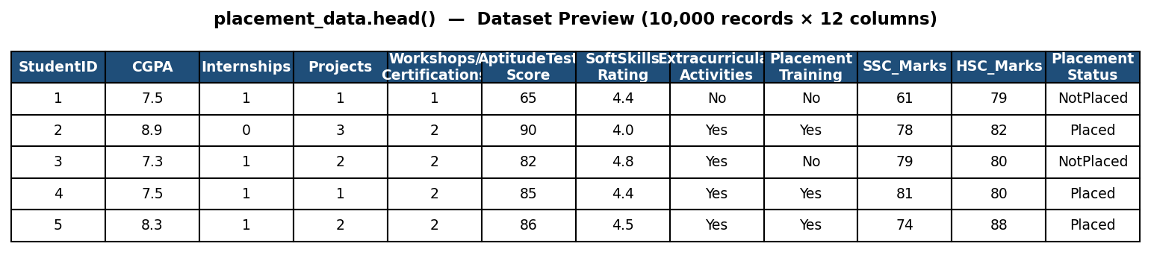
Figure 3.1 Dataset Loading and Preview

3.2.1 DATA DICTIONARY
Field Name | Data Type | Description
StudentID | Integer | Unique ID of each student record
CGPA | Float | Cumulative Grade Point Average of the student
Internships | Integer | Number of internships completed
Projects | Integer | Number of projects completed
Workshops/Certifications | Integer | Number of workshops / certifications done
AptitudeTestScore | Integer | Score obtained in the aptitude test
SoftSkillsRating | Float | Soft skills rating of the student (out of 5)
ExtracurricularActivities | Categorical | Participation in extracurricular activities (Yes / No)
PlacementTraining | Categorical | Whether placement training was attended (Yes / No)
SSC_Marks | Integer | Secondary School (10th) marks
HSC_Marks | Integer | Higher Secondary (12th) marks
PlacementStatus | Categorical | Placement status – Placed / NotPlaced (Target variable)
Table 3.2.1 Data Dictionary of Placement Dataset

3.3 TASK 3 – EXPLORATORY DATA ANALYSIS (EDA)
The third task involved analyzing the dataset to discover useful insights and identify relationships among different features. Various visualization techniques were used to understand the distribution of data and detect important trends.
Charts such as count plots, histograms, box plots, correlation heatmaps, and bar graphs were generated using Matplotlib and Seaborn. The analysis helped in identifying the most influential factors affecting student placement.
Activities Performed:
- Generated statistical summaries.
- Visualized placement distribution.
- Created correlation heatmap.
- Examined feature distributions.
- Identified important variables.
Outcome:
The analysis revealed that attributes such as CGPA, Aptitude Test Score, Placement Training, Internships, and Soft Skills Rating had a significant impact on placement prediction.
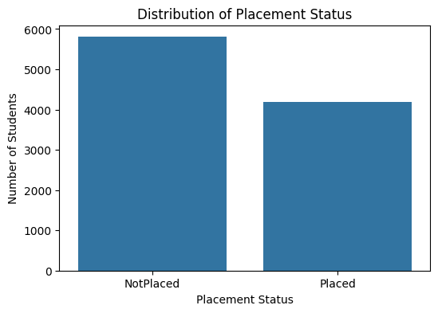

Figure 3.2 Distribution of Placement Status

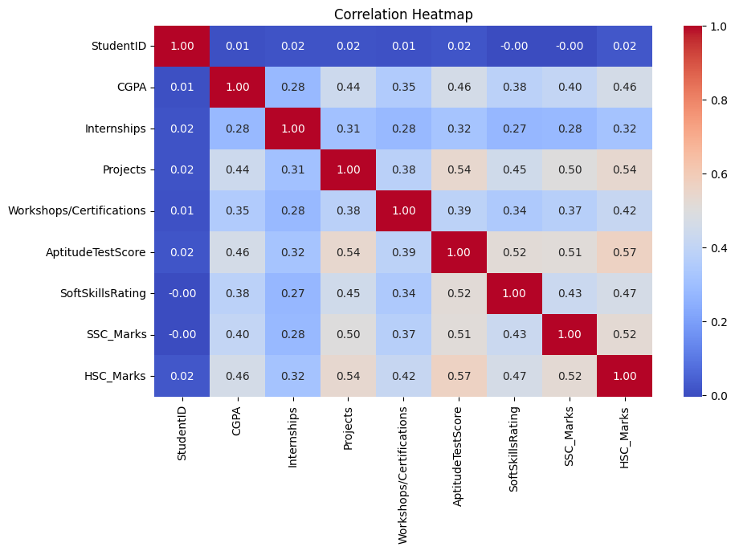
Figure 3.3 Correlation Heatmap of Dataset Attributes

3.4 TASK 4 – MACHINE LEARNING MODEL DEVELOPMENT
After completing data preprocessing and analysis, different machine learning classification algorithms were implemented to predict student placement.
The dataset was divided into training and testing sets using an 80:20 train-test split. Three supervised machine learning algorithms were trained and evaluated:
- Logistic Regression
- Decision Tree Classifier
- Random Forest Classifier
Each model learned patterns from historical student data and generated predictions for unseen records.
Activities Performed:
- Split dataset into training and testing sets.
- Trained multiple classification models.
- Generated predictions.
- Compared model performance.
Outcome:
Multiple predictive models were successfully developed for comparison.

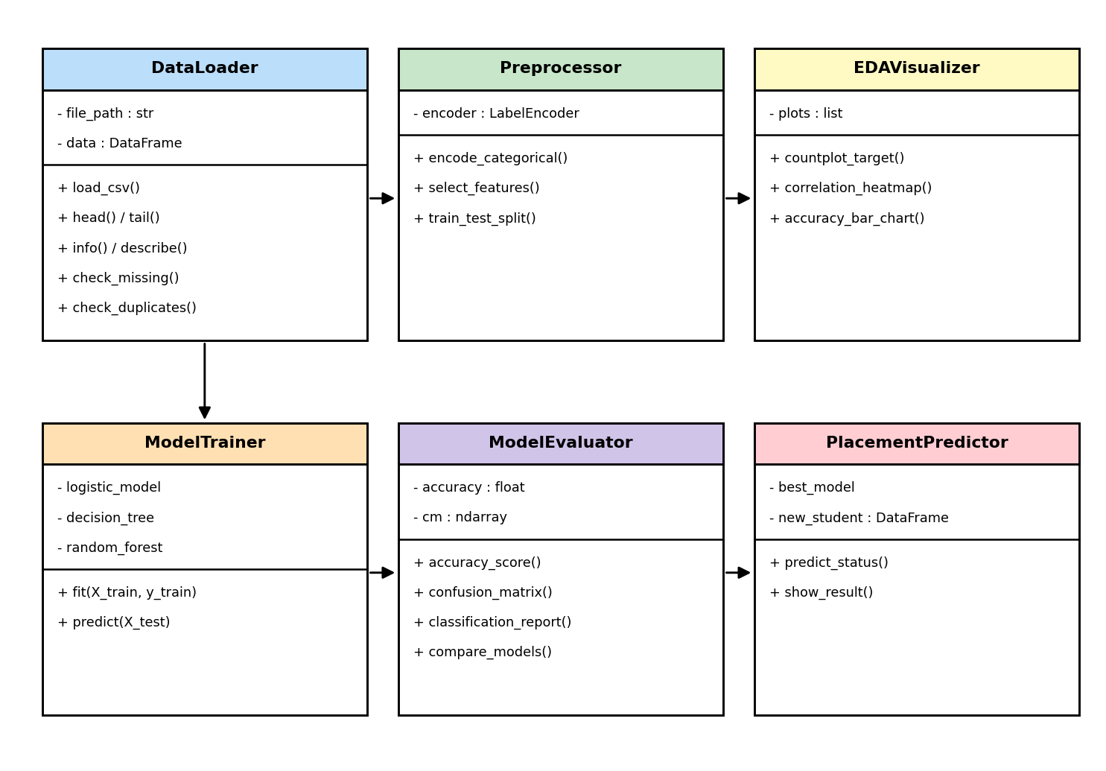
3.4.1 CLASS DIAGRAM

Figure 3.4 Class Diagram of Student Placement Prediction System

Explanation: The class diagram illustrates the logical structure of the application. It consists of six major classes: DataLoader, Preprocessor, EDAVisualizer, ModelTrainer, ModelEvaluator, and PlacementPredictor. These classes collectively perform data loading, preprocessing, visualization, model training, evaluation, and prediction.

3.4.2 ER DIAGRAM
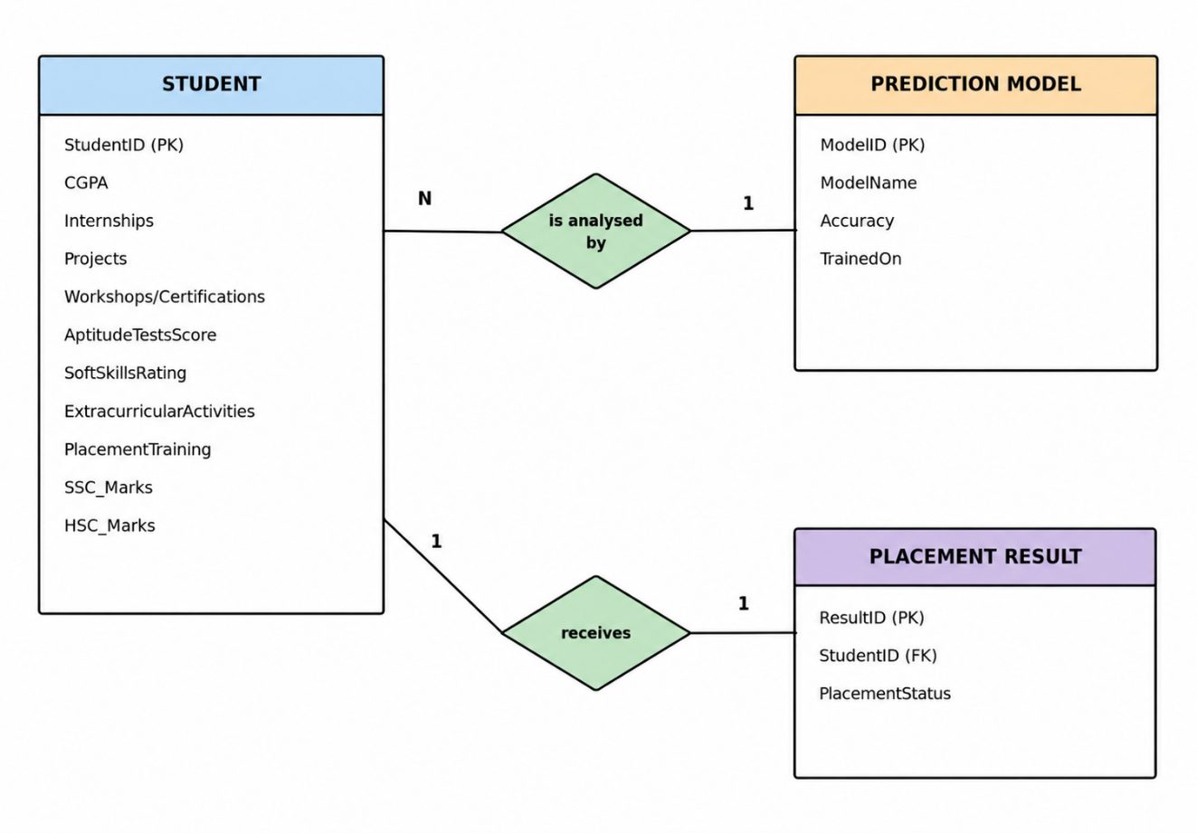
Figure 3.5 ER Diagram of Student Placement Prediction System
Explanation: The ER diagram presents the conceptual relationship among the major entities of the Student Placement Prediction System. The Student entity stores academic and personal information, which is analyzed by the Prediction Model to generate placement predictions. The generated prediction is stored in the Placement Result entity for further analysis and decision-making.

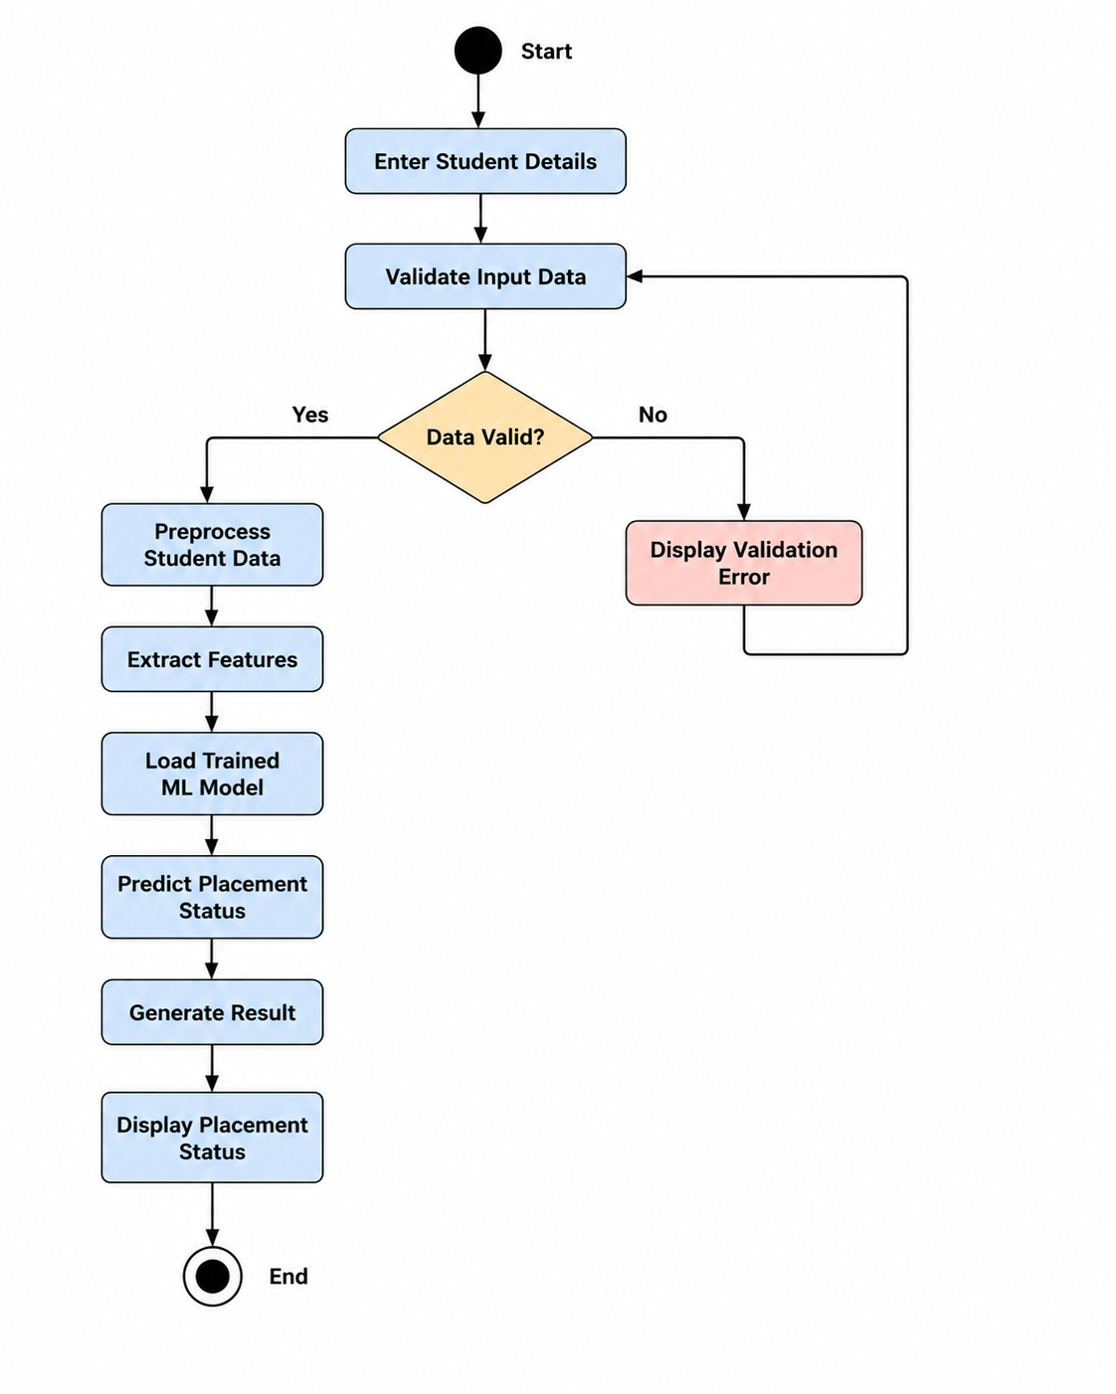

Figure 3.6 Activity Diagram of Student Placement Prediction System

Explanation: The activity diagram represents the step-by-step workflow of the Student Placement Prediction System. The process begins with entering student details, followed by input data validation. If the data is valid, the system preprocesses the student data, extracts relevant features, loads the trained machine learning model, predicts the placement status, generates the result, and displays the placement prediction. If the data is invalid, a validation error is displayed and the user is prompted to re-enter the details.

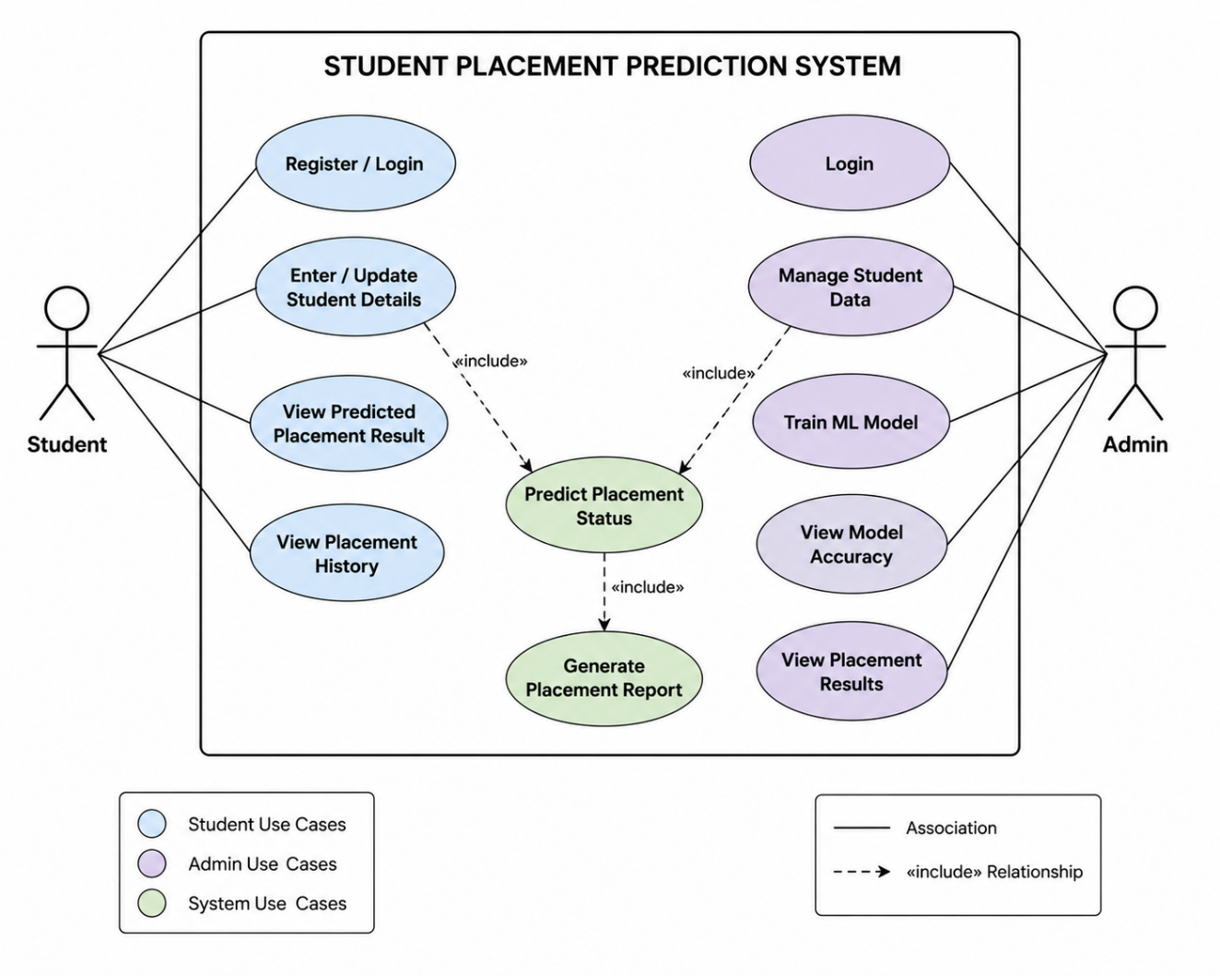

Figure 3.7 Use Case Diagram of Student Placement Prediction System

Explanation: The use case diagram illustrates the functional requirements of the Student Placement Prediction System from the perspective of two actors: Student and Admin. The Student can register, enter or update personal details, view predicted placement results, and view placement history. The Admin can login, manage student data, train the machine learning model, view model accuracy, view placement results, and generate placement reports. The central system use case, Predict Placement Status, is shared between both actors through include relationships.
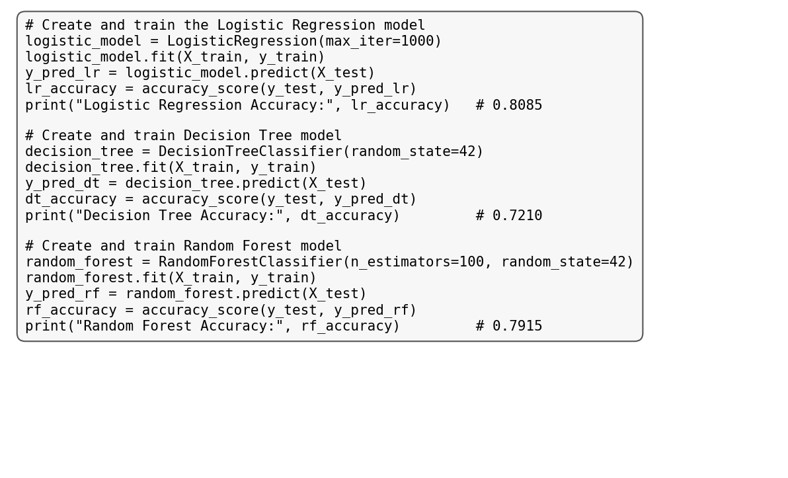
Figure 3.8 Model Training Using Machine Learning Algorithms

3.5 TASK 5 – MODEL EVALUATION
The fifth task involved evaluating the performance of each machine learning model using standard classification metrics.
Several evaluation techniques were applied to determine the effectiveness of each algorithm. The performance of the models was compared using Accuracy, Precision, Recall, F1-Score, and Confusion Matrix.
The results showed that Logistic Regression produced the highest prediction accuracy of approximately 80.85%, making it the best-performing model for this project.
Evaluation Metrics Used:
- Accuracy
- Precision
- Recall
- F1-Score
- Confusion Matrix
Outcome:
The most suitable machine learning model was selected for final deployment based on overall prediction performance.
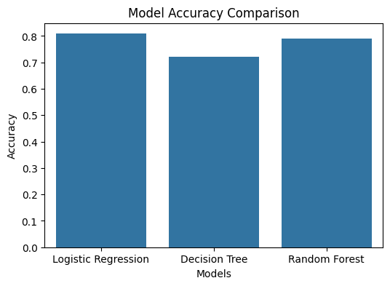
Figure 3.9 Model Accuracy Comparison

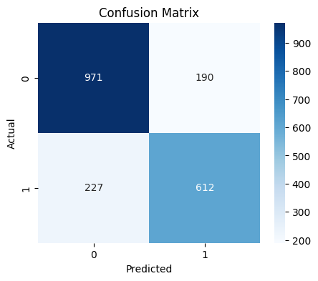
Figure 3.10 Confusion Matrix of the Selected Model

3.6 TASK 6 – PREDICTION AND RESULT ANALYSIS
Once the best-performing model was selected, it was used to predict the placement status of new students based on their academic and personal information.
Different combinations of student attributes were provided as input, and the model generated predictions indicating whether a student was likely to be Placed or Not Placed.
The prediction results demonstrated that academic performance, placement training, aptitude scores, internships, and project experience significantly influenced placement outcomes.
Activities Performed:
- Tested the trained model.
- Predicted placement status for new records.
- Verified prediction accuracy.
- Interpreted prediction results.
Outcome:
A reliable prediction model was successfully developed to assist institutions in identifying students who may require additional training before campus placements.

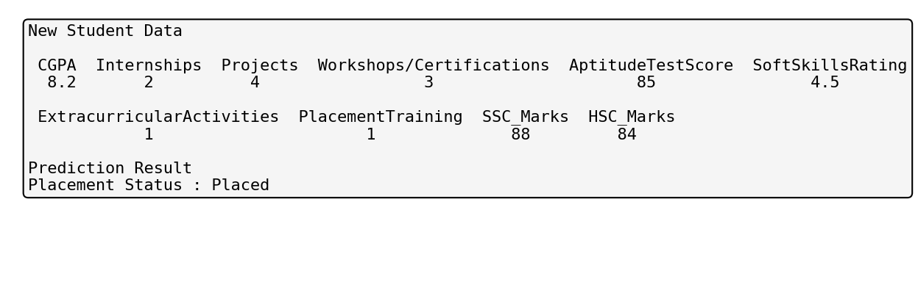
Figure 3.11 Placement Prediction Output

3.7 TASK 7 – DOCUMENTATION AND PROJECT PRESENTATION
The final task involved preparing the complete internship documentation and presenting the project to the mentors.
All project phases, including problem identification, dataset analysis, preprocessing, visualization, machine learning implementation, evaluation, and prediction, were documented systematically. The final report was prepared according to the prescribed university format, and the project outcomes were presented during the internship evaluation.
Activities Performed:
- Prepared technical documentation.
- Organized implementation screenshots.
- Created tables and figures.
- Compiled the internship report.
- Presented the project findings.
Outcome:
The internship project was completed successfully with proper technical documentation and presentation, demonstrating the practical application of Data Science and Machine Learning concepts.

CHAPTER 4 LEARNING EXPERIENCES

The Summer Internship at Sparks To Ideas, Ahmedabad provided an excellent opportunity to gain practical exposure to Data Science and Machine Learning. The internship combined theoretical concepts with real-world implementation, enabling the application of classroom knowledge to industry-oriented projects. Throughout the internship, several technical and professional skills were developed while working on the project "Student Placement Prediction and Analysis Using Data Science."

The internship enhanced problem-solving abilities, analytical thinking, and technical proficiency through continuous learning, practical assignments, and project development. Working with real datasets and machine learning algorithms provided valuable experience in handling industry-level challenges and understanding the complete software development lifecycle of a data science project.

4.1 KNOWLEDGE ACQUIRED / SKILLS LEARNT
During the internship, knowledge was acquired in various areas of Data Science, Machine Learning, and software development. The project involved working with real-world datasets and implementing multiple machine learning techniques to solve a practical problem.
Technical Skills Acquired
- Developed strong programming skills using Python.
- Learned to use NumPy for numerical computations and array operations.
- Gained practical experience with Pandas for data cleaning and manipulation.
- Performed Exploratory Data Analysis (EDA) using Matplotlib and Seaborn.
- Understood feature engineering and data preprocessing techniques.
- Learned data encoding and feature scaling methods.
- Built machine learning classification models using Scikit-learn.
- Compared multiple classification algorithms based on performance metrics.
- Evaluated machine learning models using Accuracy, Precision, Recall, F1-Score, and Confusion Matrix.
- Interpreted model outputs and prediction results.

Professional Skills Developed
- Problem-solving and analytical thinking.
- Logical reasoning and decision-making.
- Technical documentation.
- Report writing.
- Presentation skills.
- Time management.
- Team collaboration.
- Communication skills.
- Self-learning and continuous improvement.
The internship significantly improved both technical expertise and professional competencies required for a career in Data Science and Machine Learning.

4.2 INDUSTRY PRACTICES ADAPTED
One of the major outcomes of the internship was understanding how software and machine learning projects are developed in an industrial environment. Unlike academic assignments, industry projects require systematic planning, proper documentation, testing, and continuous improvement.
The following industry practices were adopted during the internship:
- Understanding project requirements before implementation.
- Dividing the project into manageable phases.
- Following a structured machine learning workflow.
- Maintaining clean, readable, and modular Python code.
- Validating and preprocessing datasets before model training.
- Comparing multiple algorithms instead of relying on a single model.
- Evaluating models using standard performance metrics.
- Preparing technical documentation for every development phase.
- Conducting testing before finalizing the prediction model.
- Presenting project outcomes professionally.
Following these practices improved the quality, reliability, and maintainability of the project while providing insight into real software development methodologies used in industry.

4.3 REAL-TIME APPLICABILITY OF TECHNOLOGIES LEARNT
The technologies learned during the internship have wide applications across various industries where data-driven decision-making is essential. The concepts and tools used in this project can be applied to solve many real-world problems beyond student placement prediction.
Python
Python is extensively used for Data Science, Artificial Intelligence, Automation, Web Development, and Machine Learning due to its simplicity and extensive library support.
Machine Learning
Machine Learning enables computers to identify patterns in historical data and make predictions. It is widely used in recommendation systems, fraud detection, medical diagnosis, demand forecasting, sentiment analysis, and predictive analytics.
Data Analysis
Data analysis techniques help organizations extract meaningful insights from large datasets, supporting informed business decisions and improving operational efficiency.
Data Visualization
Visualization tools such as Matplotlib and Seaborn simplify complex datasets through graphs and charts, making trends and relationships easier to understand.
Scikit-learn
Scikit-learn provides efficient implementations of machine learning algorithms for classification, regression, clustering, preprocessing, and model evaluation. It is widely used in research and industrial applications.
Application of the Internship Project
The Student Placement Prediction System developed during the internship can be applied in educational institutions to:
- Predict students' placement opportunities.
- Identify students requiring additional training.
- Analyze factors influencing placement performance.
- Support Training and Placement Cells in planning skill development activities.
- Improve placement strategies using data-driven insights.
The practical knowledge gained during the internship provides a strong foundation for future work in Data Science, Machine Learning, Artificial Intelligence, and Predictive Analytics.

CHAPTER 5 CONCLUSION
The Summer Internship at Sparks To Ideas, Ahmedabad provided valuable practical exposure to the field of Data Science and Machine Learning. Throughout the internship, theoretical concepts learned during academic studies were successfully applied to solve a real-world problem through hands-on implementation and project development.

The internship project, "Student Placement Prediction and Analysis Using Data Science," was successfully completed by following the complete Data Science lifecycle. The project involved understanding the problem statement, collecting and preprocessing the dataset, performing exploratory data analysis, developing multiple machine learning models, evaluating their performance, and selecting the most suitable model for predicting student placement status.

Among the implemented classification algorithms, Logistic Regression achieved the highest prediction accuracy of approximately 80.85%, outperforming the Decision Tree and Random Forest models. The analysis demonstrated that factors such as CGPA, aptitude test score, internships, projects, placement training, and soft skills significantly influence a student's placement opportunities.

Apart from technical knowledge, the internship also enhanced professional skills such as analytical thinking, problem-solving, technical documentation, communication, teamwork, and time management. Working on a real-world dataset and using industry-standard tools such as Python, Pandas, NumPy, Matplotlib, Seaborn, and Scikit-learn provided valuable insight into practical machine learning development.

Overall, the internship served as an important learning experience and strengthened the foundation in Data Science and Machine Learning. The knowledge and skills acquired during this internship will be beneficial for future academic projects, industrial training, research work, and professional career opportunities in Artificial Intelligence, Machine Learning, and Data Analytics.

5.1 FUTURE SCOPE
Although the developed model provides satisfactory prediction performance, there are several opportunities for further improvement and enhancement.
Future work can include the following:
- Expanding the dataset by including records from multiple educational institutions to improve the model's generalization capability.
- Implementing advanced machine learning and deep learning algorithms such as XGBoost, LightGBM, Artificial Neural Networks (ANN), and TensorFlow-based models to improve prediction accuracy.
- Predicting additional outcomes such as expected salary package, job role, or company category along with placement status.
- Developing a web-based or mobile-based application that enables students and placement officers to use the prediction system through a user-friendly interface.
- Integrating the system with a college placement management portal for real-time student analysis and decision-making.
- Incorporating recommendation features that suggest skill development programs, certification courses, or training activities for students predicted as Not Placed.
- Continuously updating the model using newly available placement data to improve prediction accuracy and maintain relevance over time.

The implementation of these enhancements can increase the practical applicability of the system and make it a more comprehensive decision-support tool for educational institutions and placement cells.

5.2 LIMITATIONS
The current system has some limitations: the prediction accuracy depends completely on the quality and size of the historical dataset used for training; the model considers only the attributes available in the dataset and cannot capture factors like communication skills, confidence or interview performance; the dataset may contain some bias which can affect the fairness of predictions; and the model needs to be retrained periodically as new placement data becomes available.

PROJECT REPOSITORY

GITHUB REPOSITORY:-

https://github.com/24cs73-prince/Student-Placement-Prediction

The complete source code, dataset, and PPT for this internship project are available in the above GitHub repository.

REFERENCES
[1] Python Software Foundation. *Python Documentation*.
Available at: https://docs.python.org/3/
[2] Pandas Development Team. *Pandas Documentation*.
Available at: https://pandas.pydata.org/docs/
[3] NumPy Developers. *NumPy Documentation*.
Available at: https://numpy.org/doc/
[4] Scikit-learn Developers. *Scikit-learn User Guide*.
Available at: https://scikit-learn.org/stable/
[5] Matplotlib Development Team. *Matplotlib Documentation*.
Available at: https://matplotlib.org/stable/
[6] Seaborn Development Team. *Seaborn Documentation*.
Available at: https://seaborn.pydata.org/
[7] Kaggle. *Campus Placement Prediction Dataset*.
Available at: https://www.kaggle.com/
[8] GeeksforGeeks. *Python Programming Language*.
Available at: https://www.geeksforgeeks.org/python-programming-language/
[9] W3Schools. *Python Tutorial*.
Available at: https://www.w3schools.com/python/
[10] Sparks To Ideas. *Official Website*.
Available at: https://www.sparkstoideas.com/

